**Dashboard Wireframe Report**

# Team Members

## Project Overview

This report analyzes the **Advertising Performance Dashboard** and **Student Participation & Opportunities Tracker**, which includes datasets related to enrollment, degree distributions, and advertising performance. The dashboard consists of multiple interactive sections for data visualization and tracking key metrics.

# Document Contents

* Introduction
* Dashboard Wireframe
* Conclusion

# Introduction

**Dashboard**

**Wireframe**

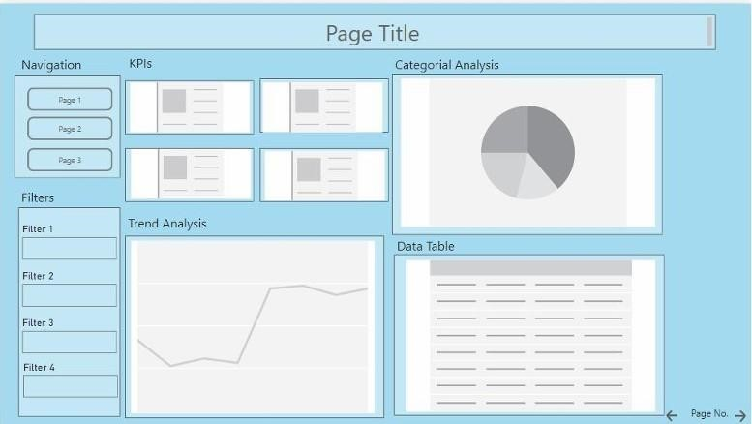

**Detailed analysis of the wireframe structure and its components:**

# Conclusion

The Advertising Performance Dashboard & Student Participation Tracker detailed in this report presents a comprehensive and user-friendly design for analyzing and visualizing key metrics related to student enrollments and advertising campaigns. By structuring the content into well-defined sections—KPIs, trend analysis, categorical analysis, and data tables—the dashboard ensures intuitive navigation and effective data presentation.

Following best practices in dashboard design, this wireframe incorporates balanced spacing, logical content grouping, and multiple visualization types, providing a strong foundation for an interactive and insightful analytical tool. The integration of trend graphs, pie charts, bar charts, and data tables allows for a holistic view of enrollment trends and advertising performance, helping users make informed decisions.

With additional features such as dynamic filtering, drill-down capabilities, and expanded campaign insights, the dashboard can be further enhanced to meet evolving analytical needs. This structured and interactive design enhances user engagement and streamlines decision-making, making it a valuable tool for data exploration, performance tracking, and strategic planning.